Practical 3: Aggregate Functions

1] Insert the collections in the database and display all the records.



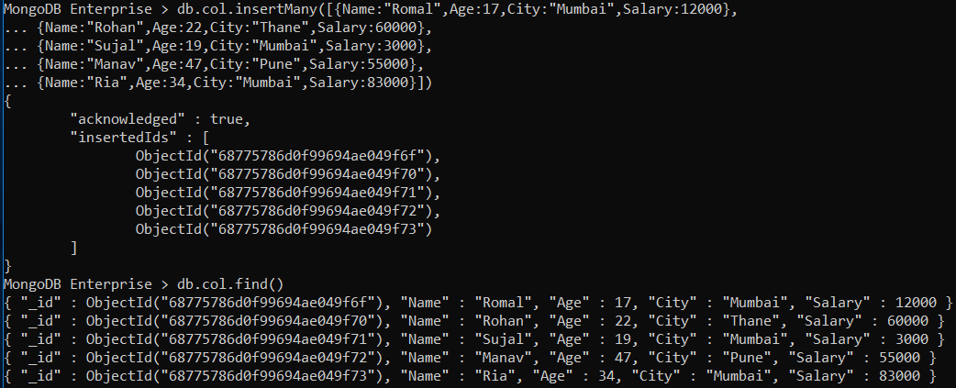

2] Group by function to get count.

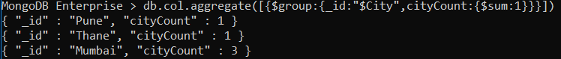

3] Sum function.



4] Avg function.

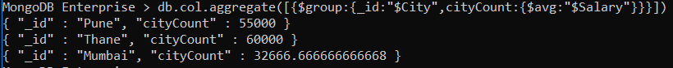

5] Min function

6] Max function

7] First function

8] Last function

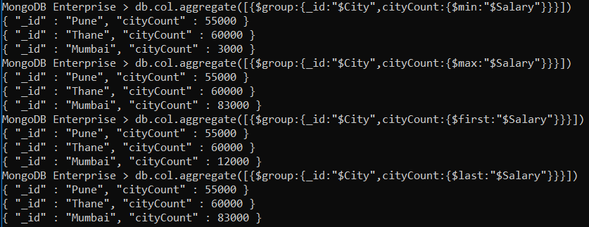

9] Push function

10] addToSet function

